Shibanxi Twilight

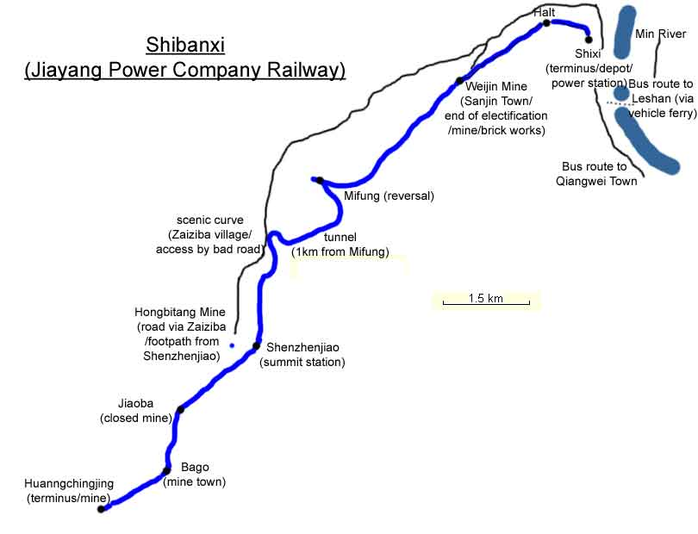
The following websites offer a profusion of details, photos and maps of the Jiayang Coal Railway at Shibanxi:

http://www.sy-country.co.uk/ (Steam lines/Sichuan/Shibanxi)
http://dialspace.dial.pipex.com/steam/trains/china212.htm
http://dialspace.dial.pipex.com/steam/trains/china213.htm

My own website has 3 pages which include stills from this DVD and which provide additional information about the footage on the DVD:

http://homepage.ntlworld.com/john.raby1/railway.html
http://homepage.ntlworld.com/john.raby1/mine.html
http://homepage.ntlworld.com/john.raby1/people.html

See also my report of my first trip to Shibanxi:

http://homepage.ntlworld.com/john.raby1/shibangxi.htm

John Raby, February 2006

