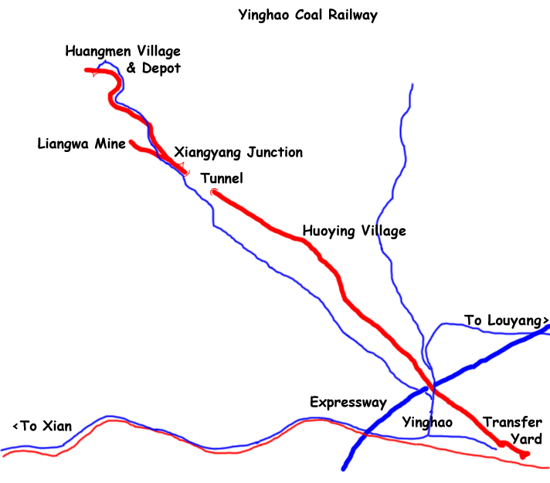
Yinghao Coal Railway

Spring 2005
Pattern of operation (daylight hours)

Operating the branch
Shift change on the railway was linked to shift change at the mine. The mine change over was at 8 am and final loads of coal were brought up by 9 am and the loco operating the mine branch (04 at the time of this visit) would take the last fulls up to the junction to make up an 8 wagon train and then head for the depot where the loco would provide hot water for the crew to shower before the new crew took over. The loco would take water and then move back to the sanding gantry and (if necessary) go to the works for any minor repairs. It would then run chimney first back to the junction. This loco was not turned at the depot nor at the junction. It reversed back down to the mine propelling 2-4 wagons at a time and then brought them up chimney first. The loco was required to position the wagons under the hopper and then move forward as commanded to load the wagons. Loco 04 was leaking badly and often struggled to bring up its load. At times, the crew would reduce the load to as few as 2 wagons in order to be able to climb the bank to the junction. After positioning the loaded wagons in the middle road, it would collect more empties from wherever they were located, or, if it had already marshalled a train of 8 wagons, wait at the junction for its next duties. This was a time for oiling round and coaling. Water seemed to be available only at the depot. At times, when the mainline loco arrived back at the junction and there were not yet 8 wagons ready to go to Yinghao, this loco (03 at the time of my visit) would go down the branch (after turning on the triangle at the junction) to double-head the loads up the branch. This operation, which happened fairly regularly, seemed to occur without any obvious means of signaling.

The mainline
The mainline loco would normally take the final load of 8 wagons to Yinghao after the mine shift change. On arrival in Yinghao, it would position the first wagon over the tippler and then run round and go beyond the tippler on an extension of the mainline to the triangle. After turning, it would come on the mine end of the train and push the loads back over the tippler where they would be unloaded. The wagons were of a design where the body could be tipped to one side so the load could be discharged. After all the wagons had been unloaded, the train would return to the junction. The railway crosses a local main road which is controlled by a staffed level crossing. The crossing crew of 2 men worked in shifts. They only knew that a train was approaching by its audible warning (and a developed sense of when the next train was due). The line then climbed gradually through the fields for several kilometres. The train often stopped at the village en route, officially to build up steam and I think the crew could also telephone to the junction from the old station. Unofficially, this was where around 10 ‘cleaners’ would jump into the wagons to recover any coal dust left in the wagons. Others would also dust the coal off the sides of the wagons. The dust was used locally to make coal briquettes for heating and cooking. On leaving the village, the train would return to the junction passing through the short (cut and cover) tunnel at the summit of the line. In normal operation, the loco would leave the train in the middle of the through road to the depot at the junction opposite the station building and turn on the triangle. It would then take 8 full wagons, if ready, down to Yinghao. If 8 wagons were not ready, it would go down the mine branch to assist the mine branch loco bringing up the last wagons. At shift change, the train of empties would be taken beyond the junction station towards the depot and the empties would be reversed into the siding for the empty wagons. This allowed the mine branch loco to run through the station on its return from the depot. The loco would then go chimney first to the depot for crew change. The pattern at the depot was similar to that for the mine branch loco except that, at some point, the loco would be turned on the triangle ready to head chimney first back to the junction.

In the week that I was there, only 2 locos were used. Other locos in the depot and works area were being worked on but no other loco was in steam. Loco 03 was in good condition but loco 04 leaked badly although it managed to struggle on. I believe that at busy times (during the time of increased coal production for winter), three locos operate the system but I was not able to observe their pattern of operation.

The next shift change happened around 5 pm for the mine branch loco and 6 pm for the mainline loco. Production of coal always took a while to resume after shift change and, at the time of my visit, the railway was able to keep up with coal production so there was not a build up of coal in the coaling hopper at the mine.

Both locos were coaled at the junction by hand from an adjacent full coal wagon. A metal grid was erected on the tender which sorted the fine coal from any larger bits. The larger bits were not used on the engine but were probably used for staff fires instead.

For further details on this railway, go to
http://rcswww.urz.tu-dresden.de/~menius/line/henan-yinghao.htm
These notes accompany the DVD ‘The Yinghao Coal Railway’. For details of all my DVDs see http://homepage.ntlworld.com/john.raby1/dvds.html or email jraby@waitrose.com

John Raby
April 2006

