Dahuichang Limestone Railway

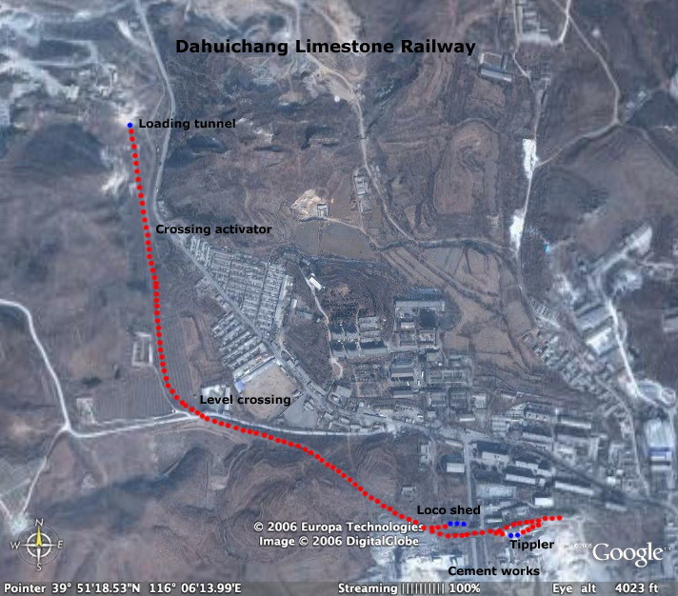

This line is extensively covered at:

http://www.sy-country.co.uk/ (go to Steam Lines / Beijing City / Dahuichang Limestone Railway)

The reference to my own report on this page can now be found at:

http://homepage.ntlworld.com/john.raby1/dahuicha.html

John Raby
October 2006

