Viseu de Sus – Romania’s Last Logging Line
Details of the DVD contents

Depot & Yard Slideshow
I shot these pictures as digital stills rather than video as there was a lot of static interest but not much action. The sequence is roughly arranged as:
Depot/shed area
We see all 4 active steam on shed (see below for details of Elvetia, Cozia 1, Mariuta and Krauss) along with glimpses of the 2 red line diesels and 2 shunters (Ecaterina and Cristina). The shed also has a standard gauge road which was closed and empty. In a separate shed, we see 764 469 (a Resita loco owned by R G Holz) being worked on.
Yard
We then move away from the shed towards the outer yard with shots of the railcar (see Trip up the Line) and snow ploughs for the steam locos. From outside the yard we get our first view of some of the road rail conversions from minibuses.
Outer yard
The single-track line from the hills divides into 2 and one road goes to the shed, passenger station and log yard and the other to a different section of the log yard. Although not confirmed, it seemed that logs from different tree types or perhaps different diameter logs were divided at the outer yard for separate processing.
Log trains generally move by gravity down to the log yard and there is a decent gradient built in to assist this. We see a selection of log wagons before a shot of a disused signal at the approach to the outer yard.
Dumped stock
The yard is full of dumped steam and all the working steam locos are imports from other lines. Most plates have been removed so establishing identities would be a real challenge. There is also a dumped standard gauge diesel.
Road Rail conversions
We see minibuses and a Russian truck converted to rail use and a new conversion in progress. This happened outside our pension and made significant progress while we were there. The vehicle is a long-wheelbase Ford minibus from Austria. All conversions have a turntable built in for turning the vehicle. Private operators are allowed to operate a taxi service up the line around the logging and tourist trains. (Normal train operations are 6 am, 7 am logging trains up, 8:30 tourist train up. Returns are roughly 5 pm tourist train, 6 pm, 7 pm logging trains.)
Passenger station and log yard
Buried inside the complex is the passenger station used for the tourist trains and a section of dual gauge track. The logs are unloaded near here (see Logging section).
Signs & Documents
We see a map of the railway (to Novat only – see below for full map of the system), R G Holz sign, and various staff notices about trains and the shed status board for the days we were there.

The music used is authentic Romanian folk music. On the bus over from Cluj Napoca we were treated to a video of the same.

Trip up the Line
Sunday 1 June was our first day and there is normally no line work (logging or tourist train) on Sunday so we should have had the line to ourselves. However, it was an election day and the company ran a rail car to bring people down to Viseu de Sus to vote. The loco we used was Elvetia (=Switzerland) the working Resita 0-8-0T owned by the Swiss preservation group (for details of the group see websites below). The loco starts off with a nameplate on the smokebox but Bernd requested that it be removed for the trip. Our train was a typical one of log wagon, crew carriage and empty logging sets. Unlike many charters on other lines in the world where people arrange for ‘demonstration freights’, we actually delivered these empty sets and brought down 3 pairs loaded.
Our first run past is in gloomy weather just before Valea Scradei where most trains stop to do a bit of shopping. In the morning, instant coffees with shots of local firewater get the crew going. The old couple we see in traditional dress were waiting for the railcar to take them to vote. At Novat (just before Delta Novat junction) there is a passing loop and we found the railcar here ready to return to Viseu de Sus. After that we had the line to ourselves for the rest of the day.
We pass the Novat Valley line branch at Delta Novat before taking water using the siphon that all the locos have at km 15.4.
The scenery gets more attractive and we reach Cozia (km 18.6), Novicior (km 20.6). Just before Botizu (km 26.2) are 3 tunnels which we see from the train. Along the way we have multiple run pasts culminating in one just after Botizu that requires you to cross the river balancing on two logs. The affect in the middle where the river is flowing at its swiftest was a most disturbing sensation. Having done this in both directions, I was ready to ride the last wagon of the train (a pw trolley) which was also quite exciting being both unsprung and close to the ground. We then had a water stop at km 29.2 and continue to Faina (33.2) which is the destination for the steam tourist train and also a major logging centre. More run pasts follow as we ride the train to Valea Babei (km 38.3) for an overnight stop before continuing to Comanu (km 43.3). The line above Valea Babei is not currently used by the company although it may be used by road-rail minibuses carrying the border police to their posts. One rockfall had to be cleared before we could make it to the effective end of the line at Comanu. The Ukrainian border is very close at this point and this is a major area for illegal migrants to attempt to enter the EU. All km distances on this trip are slightly inflated as the active narrow gauge line starts at km 3.2 and no longer reach km 0 at the interchange with the standard gauge (and perhaps never did).

We had Elvetia for one more full day on the line but footage of this just wouldn’t squeeze onto the DVD.

Logging
Bernd had arranged for the workers at Valea Babei to demonstrate traditional logging with horses and loading the logging sets by hand. This was a fascinating session and provided a stark contrast with the mechanical hauling and loading we see later. One thing they couldn’t leave out was the chain saw which replaced the traditional axe to cut down the tree.
We then take our one log set and collect two more for the return to Viseu de Sus. Three is a very small number when compared with the 21 sets that the diesels can haul but we did see the tourist train bringing down three as well so it may be quite common to see steam hauling a small number of log sets most days. We pass one of the diesels with cattle being brought up to summer pastures and then find our way blocked by a flock of sheep being herded up the line. Loaded logs trains are not great for video being bunker first downhill and very slow. Although we see a few run pasts with logs, this, it turns out, is not the video highlight of the trip. We had a derailment (the only one of the trip) but after a few failed attempts with the re-railing irons, the bogie was back on the rails and we continued back to the sawmill where the logs are gravity fed to the unloading derricks before diesel shunter Cristina goes on the end for the unloading process. Unloading is slow, so we see a much edited version here. Of surprise to all was that although we could understand that the lift might be slow, returning the wires to the ground prior to unloading the next wagons was equally slow.
We were not allowed into the R G Holz sawmill so we visited a small-scale sawmill to see how the logs are cut up into planks.
On Wednesday 4 June, we took Cozia 1 (Reghin 0-8-0T) up the line and found our way blocked by mechanical loading. Once loaded, Cozia 1 pushes the logs up to the nearest siding before continuing to Faina. On our return we picked up a decent train of initially 5 (but later more) disconnects to bring down to the mill. Elvetia with the tourist train and 3 log sets catches us up and later passes us at Cozia. On return to the yard, we see examples of gravity working of the log sets including the trains brought in by the two diesels.

Cozia 1 4 June
This is the one working steam loco owned by R G Holz. As such, its role is normally stand by for the two line diesels. However, the Swiss preservation group’s locos are also available and locos owned by both groups are used flexibly on the tourist train and for non-enthusiast. charters (or perhaps to occasionally substitute for a failed diesel on log trains).
Once out on the line, we stop to let the tourist train with Elvetia at the head pass at Novat before a run past at Delta Novat. Following this, I had my one cab ride of the trip to the water stop (km 15.4) and we proceed to Novicior (the shot with the dog in the foreground) and the final tunnel just before Botizu. We returned with a log train which can be seen in the Logging footage.

Krauss 5 June
On our one wet day, we took Krauss as far as we could up the Novat Valley line which turned out to be only about 1 km as logging vehicles have damaged the tracks. It’s not clear if R G Holz plan to repair the track or use the railway for logging this valley. All logging here is currently by tractor using the river as a road.
Krauss is the smallest steam loco and the one least trusted for line work so we had Cristina running with another train ahead of us initially. We had a run past at a former log yard below Valea Scradei and one of our regular stops at the shop before the rain started. Then, Cristina had problems herself and returned light to the depot. Krauss soldiered on in the rain. With photography challenging and having run out of line to explore, we returned to the water stop at km 8.5 which also happens to be a trout farm. After a lunch of rainbow trout and beer, we returned early to the depot after our shortest day.

Mariuta 6 June
On our last full day and the last day of the charter, we took Mariuta to Botizu. Cozia 1 was operating the tourist train and struggled to exit the yard. We followed on with reasonable weather and some good run pasts at Valea Scradei, before and at the water stop (km 8.5) and at Delta Novat on both the branch and mainline. Note that one of the train crew seems to be sleeping off the mother of all hangovers on the log wagon during many of these run pasts. One of the best run pasts of the trip was performed just after Delta Novat. A nice touch is the working stove in the carriage with its own trail of smoke which is visible in several of the run pasts. After several more run pasts we reach Botizu, the end of our trip, were a road-rail conversion is waiting to cross us.

At the beginning of the tour, Bernd said that most of the good photo opportunities would be in the first 2 days and that anything else would be a bonus. As it turned out, opportunities were spread fairly evenly across the whole 6 days. What I enjoyed most was the working railway that was going on around us (even on the Sunday) and the mix of real as well as realist narrow gauge logging scenes. We can be fairly certain that on a normal day during the tourist season, only one steam loco will be working and on the tourist train. However, it could well be taking out some logging sets with that train and bring back fulls. What can’t be ruled out is that steam will occasionally substitute for diesel on a genuine log train but your chances of arriving in Viseu de Sus unannounced and getting lucky must be slim.

Useful Websites
http://www.users.waitrose.com/~jraby/viseu08.html
My own overview of the trip
http://www.farrail.com/pages/touren-engl/romania-2008-06.html
Farrail details of the tour. As yet, there is no trip report but it should be there eventually at http://www.farrail.com
http://www.wassertalbahn.ch/
Hilfe für die Wassertalbahn in Rumänien – the Swiss group involved in preserving the line and its equipment. Note the traditional German name for the line.
http://www.ecotours.ro/gb/ecotours.html
The local organisation that works with the Swiss group and R G Holz to operate tourist trains on the line.
http://www.cffviseu.ro/tourism.htm
Alternative information to EcoTours on the tourist operation.

Reports from previous years
http://www.internationalsteam.co.uk/trains/roman11.htm
2004 report
http://www.farrail.net/pages/trip-reports-engl/romania-viseu-2006-10.html
2006 report

Please let me know of any other good websites for the CFF Viseu de Sus.
John Raby
jraby@waitrose.com
July 2008
Map of the line – provided to Farrail tour participants
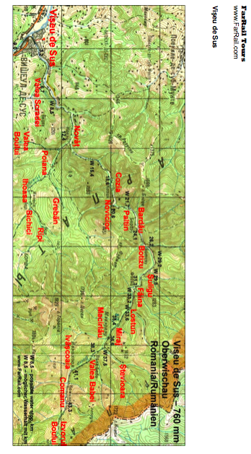
Loco details – provided to Farrail tour participants

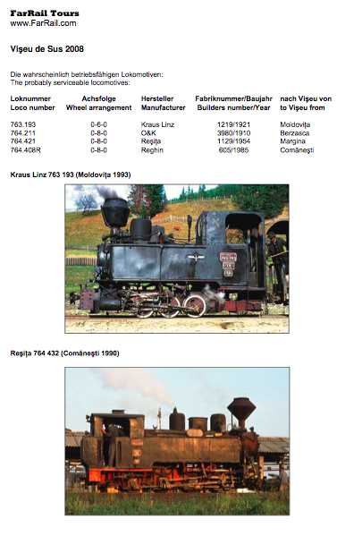
Loco names
‘Krauss’
‘Mariuta’
‘Elvetia’
‘Cozia 1’

