Yabuli Forest Railway
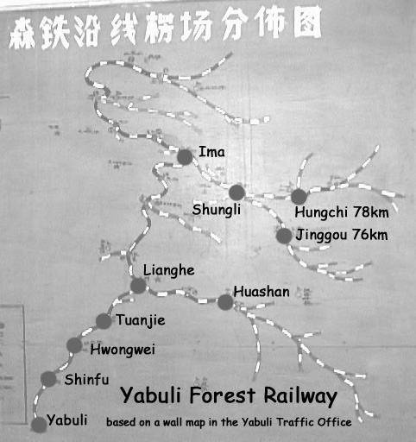
At the time of our visit, the sections in use were limited to those named above. The major climb that required banking or double-heading was between Hwongwei and Shinfu. The line closed at the end of the season 1998-9.

Notes on the sequences shown on the DVD
Beyond the Climb
From Hongwei to Shinfu, the route starts of relatively flat. We never got to Hongwei itself or further out. In those days, visitors tended to remain close to the log yard and mainline terminus. Unfortunately, Yabuli did not survive long enough for us to plan to travel out by public or chartered railcar and to remain overnight up the line. We were among the last visitors to a logging line well known but in terminal decline. In the first sequence filmed on January 6, 1999 around 10 am, permanent way staff make repairs to the track prior to a log train passing assisted by a second loco banking.
The Climb
This sequence shows the start of the climb on January 2 in murky conditions. A train, apparently double-headed and bank is actually being used to ferry a failed loco (the second loco) back to Yabuli for repair. On a sunny day on December 31st 1998, we got our first look at the Yabuli bank from near the top. On January 1st, the weather was less obliging when we went back for more action. However, the weather improved as the day went on. January 2 was also blessed by reasonable weather. We see a variety of sequences of trains attacking the summit in the period up until January 6. Although in most cases, trains were banked by a loco on the rear, in one sequence we see how two short trains have been combined with the second loco cut into the middle of the train.
We also see how the banker would pull up at the top of the climb and then either follow the train to Shinfu if there was no other train to bank or drop back down to Hongwei to bank another train. A banker continuing to Shinfu was a sign to us that no more loaded trains were due for several hours and this was our signal to return to Yabuli and possibly drive over to Weihe which was only about 30 minutes away on the new expressway.
Climb to Village
When the banker had no more work, it would come on front of the train at Shinfu to double head into Yabuli. We see this happen on January 5 around 10:30.
The Village
The village was just outside the yards at Yabuli and the empties made a fine sight as the worked uphill through the village on their way to the forests.
Yabuli Yard
Finally, we see shots taken around the narrow gauge yard and station at Yabuli. This was somewhat distant from the standard gauge line and there was a connection from Yabuli Yard to a transfer yard. B*309 is a Polish loco. The B stands for Bolanda (the Chinese word for Poland) and the * represents the socialist friendship then shared by both countries. The C2 class is often wrongly described as a version of the Polish Px48. In fact, they are based on a Russian design but some were build in Poland and other East European countries for China. In China, the considerably rarer C4 class is related to the Polish Px48. At the time of our visit, two railbuses worked daily services to Huashan and to Hungchi/Jinggou but to travel on the service, you had to be prepared to spend the night up the line before returning the next morning. I am sure we have done that on a return trip, had the line survived.

Xilin Mineral Railway
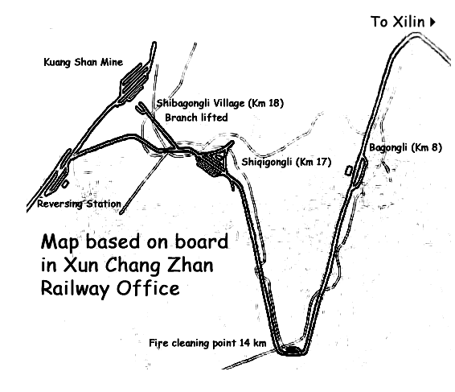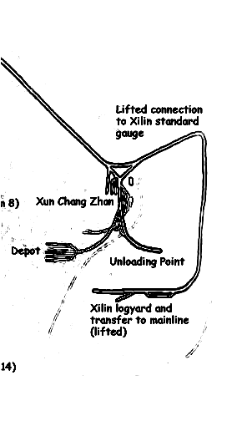
Notes on the sequences shown on the DVD
Xilin is north of Nancha which itself is north east of Harbin. This area once had many narrow gauge forestry lines but Xilin was the only one to survive converted to a mineral line. We visited Xilin in March 2001. It was a sudden addition to the trip as the narrow gauge Huanan coal line which we intended to visit was still closed for its long winter break. Huanan still survives so fate helped us here. Xilin closed later in November 2001.
Kuangshan Mine
The underground railway at Kuangshan used small overhead electric locos.
Empties would be tripped up the steam climb to the mine in short trains or doublehead. Loaded trains would also be worked down in the same way. Trains were split and combined at Shiqigonli which in Chinese means kilometer 17.
Shiqigongli Triangle
Locos would be turned on the triangle here and short trains of fulls would be combined to be worked down the gentler gradients to the processing plant. Trains of empties would be split or double headed here to reach the mine. Locos could also take water here.
Between Bagongli (km 8) and Shiqigonli (km17)
The line did a dogleg to follow a gently graded route but the final section to Shiqigonli was still a challenge for the ailing locos and trains were sometimes combined to allow a healthier loco to assist a weaker loco. Some logging was taking place in the area but the railway wasn’t used to carry out the logs. However, from the fire cleaning point there were signs of a branch on the former logging railway. Xilin was one of several logging lines including Huanan which found new lives as mineral lines.
Bagongli
This sequence of night shots show what a modern digital camera with a big zoom can do in conditions that the traditional still photographer would have given up on. There would have been more but the loaded train had developed a problem and we left before this had been sorted out.
Xunchangzhan
The former logging line facilities, the traffic office, shed and workshop were all used for the mineral line but trains no longer ran down to the standard gauge interchange sidings. Instead, loaded trains were propelled to the processing plant and tipped. Clearly Xilin once had a passenger service and the former forestry line was certainly much longer than the truncated mineral line and would have had many branches. We see the dumped stock from a much bigger operation outside the shed. When we visited, three steam locos were hauling all the trains. The line was totally dependent on the mine and when the mine closed, so did the railway. Also affected would have been the village Shibagongli were most families depended on the mine for employment. I’m not sure if we ever really knew what the heavy rocky ore carried by the line was but it could have been lead.

John Raby
jraby@waitrose.com

