Xingyang Brickworks Railway

The railway is 15 km west of Zhengzhou, Henan Province on the line to Luoyang and Xian. The line is 762mm gauge, approximately 5km long and uses C2 0-8-0 steam locos.

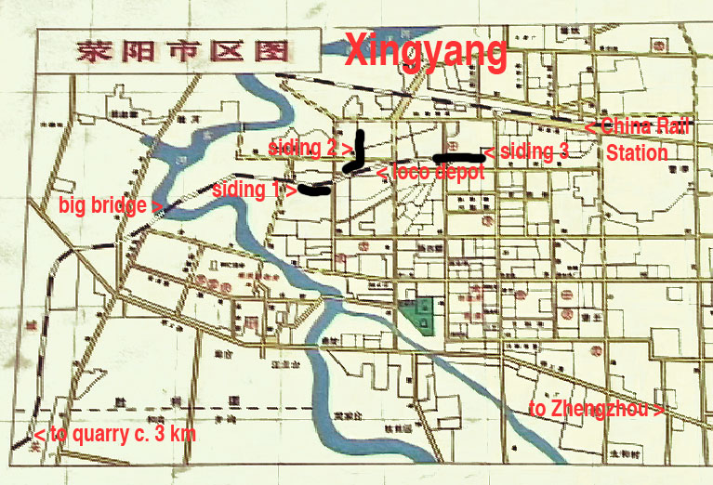
This annotated map is based on one in the Xingyang China Rail station which sees a few stopping trains each day. (Update: this service has now ceased.)

For additional maps see http://www.sy-country.co.uk/ under Steam Lines/Henan Province.

The line operates with one loco in steam. The other loco is often in pieces under repair and should the working loco fail the service will be suspended until it is repaired. There are other reasons for suspension of service:

-too wet to quarry the clay
-loading equipment breakdown
-power cuts affecting electric powered loading gear
-over supply of clay and/or bricks

This makes a visit to find the line working something of a lottery.

The line serves 3 sidings with one or more brickworks alongside each siding. Sidings are served as required. Watching the pointsman is the best informal way to find out which siding will be served next. Tracking them down in their hut and asking them would be a more reliable method. The closest siding to the quarry requires fly shunting prior to or after unloading. The middle siding is fly shunted before unloading and the method for the furthest siding was not observed.

The loco takes the empties to the quarry tender first and reverses the train back into the loading siding. Wagons are loaded one-by-one and two staff use chocks to stop and then allow the wagons to roll forward to be filled. When all wagons are filled, the loco runs round and hauls the train chimney first back to the sidings.

The line is initially uphill to a summit in a deep cutting, then downhill to the big bridge and uphill again to a final summit before the first siding. The bridges over the line are impressive brick built affairs but lack any superstructure making them a health and safety nightmare. It’s almost unbelievable that no safety walls along the top of the bridge were built to stop anyone walking or driving off the bridges onto the railway. Some of the bridges have 1980s political slogans. My favourite is ‘Repel the foreign invaders’. I wonder if they had railway enthusiasts in mind.

The hoppers are side tipping and there are chains to release before they can be tipped. The train is loose coupled and one or more staff sit on the loaded wagons to apply the wagon brakes on the downhill stretches.

The day shift is from around 0700 until 1600 with a one hour break for lunch. There is usually a second shift from 1600 and from the hotel near the China Rail station, steam whistles can often be heard in the evening/early morning.

This DVD is based on a visit in May 2005.

For further information about the railway see http://www.sy-country.co.uk/ or http://www.chinasteam.com/trains/china238.htm

John Raby, Radcliffe on Trent, Nottingham, 5 May 2006
‘LINESIDING with John’, http://www.linesiding.co.uk

